User35 : Othman Emara

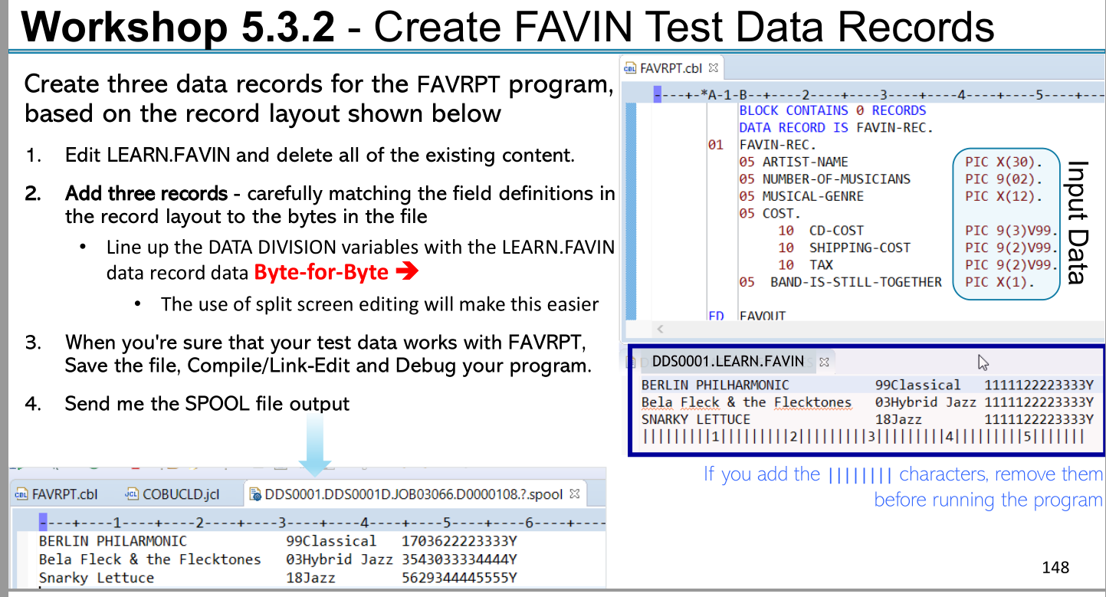

Answer :

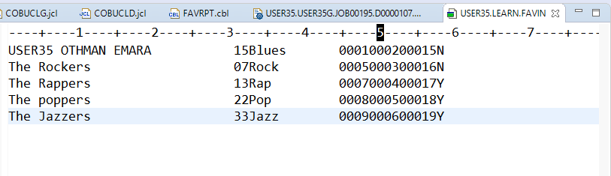

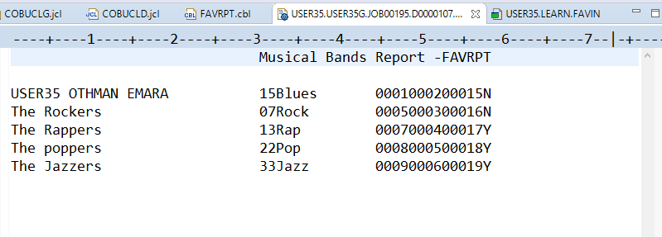

IDENTIFICATION DIVISION.

PROGRAM-ID. FAVRPT.

\*\*\*\*\* This MODULE Workshop 5.3.1b - Create new COBOL program

\*\*\*\*\* THAT USES A FILE READ

ENVIRONMENT DIVISION.

INPUT-OUTPUT SECTION.

FILE-CONTROL.

SELECT FAVIN1 ASSIGN TO FAVIN

FILE STATUS IS FAVIN-F-STATUS.

SELECT OUT2 ASSIGN TO FAVRPT.

DATA DIVISION.

FILE SECTION.

FD FAVIN1

RECORDING MODE IS F

LABEL RECORDS ARE STANDARD

RECORD CONTAINS 80 CHARACTERS

BLOCK CONTAINS 0 RECORDS

DATA RECORD IS FAVIN-REC.

01 FAVIN-REC.

05 ARTIST-NAME PIC X(30).

05 NUMBER-OF-MUSICIAN PIC 9(02).

05 MUSICAL-GENRE PIC X(12).

05 COST.

10 CD-COST PIC 9(3)V99.

10 SHIPPING-COST PIC 9(2)V99.

10 TAX PIC 9(2)V99.

05 BAND-IS-STILL-TOGETHER PIC X(1).

FD OUT2

RECORDING MODE IS F

LABEL RECORDS ARE STANDARD

RECORD CONTAINS 80 CHARACTERS

BLOCK CONTAINS 0 RECORDS

DATA RECORD IS FAVOUT-REC.

01 FAVOUT-REC.

05 ARTIST-NAME-OUT PIC X(30).

05 NUMBER-OF-MUSICIAN-OUT PIC 9(02).

05 MUSICAL-GENRE-OUT PIC X(12).

05 COST-OUT.

10 CD-COST-OUT PIC 9(3)V99.

10 SHIPPING-COST-OUT PIC 9(2)V99.

10 TAX-OUT PIC 9(2)V99.

05 BAND-IS-STILL-TOGETHER-OUT PIC X(1).

05 FILLER PIC X(20) VALUE SPACES.

WORKING-STORAGE SECTION.

01 HEADER-1.

05 FILLER PIC X(30) VALUE SPACES.

05 FILLER PIC X(30) VALUE 'Musical Bands Report -FAVRPT'.

05 FILLER PIC X(20) VALUE SPACES.

01 DEBUG-1.

05 FILLER PIC X(5) VALUE 'DEBUG' JUSTIFIED RIGHT.

05 FILLER PIC X(13) VALUE ' file status:'.

05 FAVIN-F-STATUS PIC X(2).

05 FILLER PIC X(4) VALUE ' LR:'.

05 LASTREC PIC X VALUE SPACES.

88 STELL-THERE-REC VALUE ' '.

88 NO-MORE-RECORDS VALUE 'Y'.

05 DEBUG-MSG PIC X(30).

77 COMPUTED-COST PIC 9(5).99 .

PROCEDURE DIVISION.

OPEN INPUT FAVIN1.

OPEN OUTPUT OUT2.

WRITE FAVOUT-REC FROM HEADER-1.

MOVE SPACES TO FAVOUT-REC.

WRITE FAVOUT-REC AFTER ADVANCING 1 LINES.

\* Prime Read

PERFORM READ-RECORD .

PERFORM UNTIL LASTREC = 'Y' OR NO-MORE-RECORDS

PERFORM PROCESS-RECORDS

PERFORM WRITE-RECORD

PERFORM READ-RECORD

END-PERFORM

PERFORM CLOSE-FILES

STOP RUN.

READ-RECORD.

READ FAVIN1

\* AT END MOVE 'Y' TO LASTREC

AT END PERFORM END-OF-FILE

NOT AT END PERFORM PROCESS-RECORDS

END-READ.

PROCESS-RECORDS .

\* MOVE ' PROCESS-RECORDS . ' TO DEBUG-MSG .

\* WRITE FAVOUT-REC FROM DEBUG-1.

COMPUTE COMPUTED-COST = (CD-COST + SHIPPING-COST + TAX).

WRITE-RECORD .

\* MOVE ' WRITE-RECORD . ' TO DEBUG-MSG .

\* WRITE FAVOUT-REC FROM DEBUG-1.

MOVE FAVIN-REC TO FAVOUT-REC.

WRITE FAVOUT-REC .

CLOSE-FILES.

\* MOVE ' CLOSE-FILES ' TO DEBUG-MSG .

\* WRITE FAVOUT-REC FROM DEBUG-1.

CLOSE FAVIN1.

CLOSE OUT2.

END-OF-FILE.

MOVE 'Y' TO LASTREC .

\* MOVE ' END-OF-FILE ' TO DEBUG-MSG .

\* WRITE FAVOUT-REC FROM DEBUG-1.